

**Group Meeting #2**

The meeting of TeamSix has decided at Discord at 28th March 2021.

**Attend present**

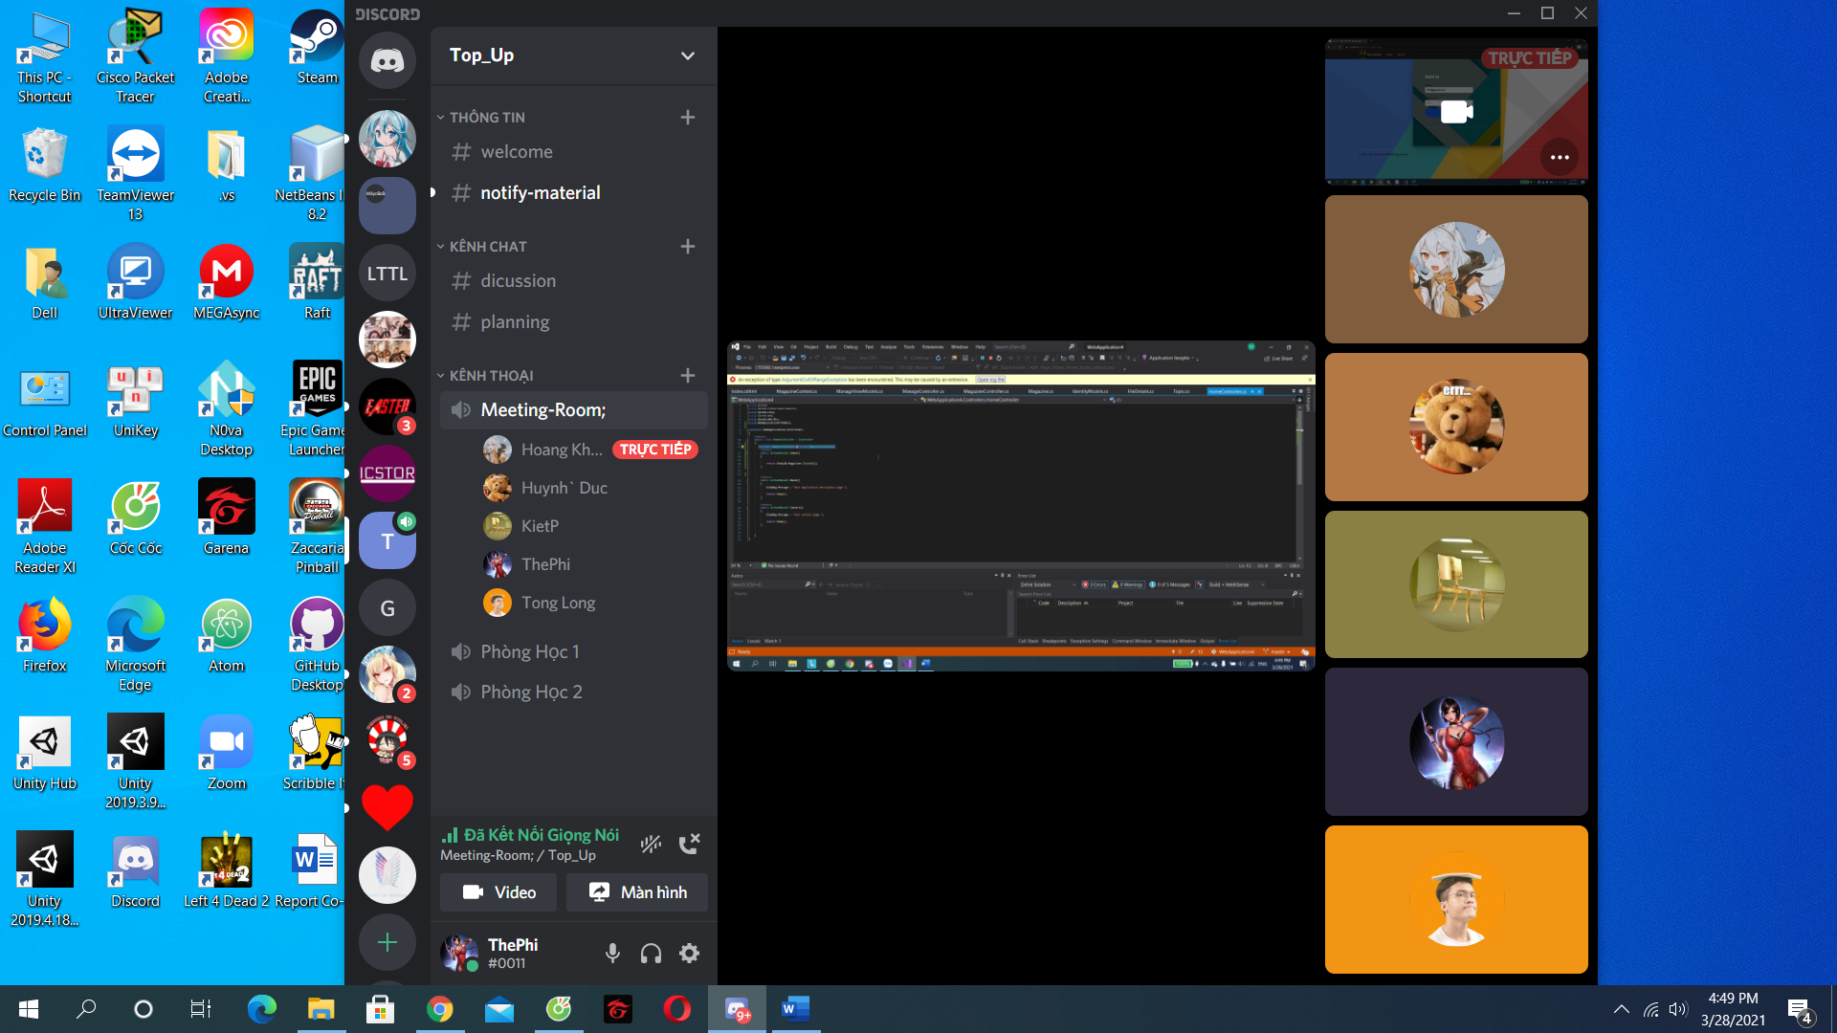

**There is 6 members in meeting:**

Pham The Phi

Hoang Khanh Son

Trinh Huynh Duc

Tong Dam Thang Long

Pham Tuan Kiet

**Member Not Attendance**

Nguyen Hoang Nhan

**Report about**

**Discuss about admin’s function, test function and design layout .**

**Time Meeting**

An initial team discussion about the project was held on 28th March, 2021 at 16h30.

**Approve comments during the meeting**

Everyone agrees

**Unfinished Work**

Follow up project.

**Next Work**

Work will hold at the next meeting at 4th April 2021.

**Work progress**

Fine